

AA DSC Solution

Prepared for

ABB Enterprise

10/17/2016

Prepared by

Boklyn Wong

Senior Consultant

boklynw@microsoft.com

Table of Contents

1 Overview 2

2 Add/Update DSC Configuration 2

3 Create azure automation variable. 6

4 Create azure automation credential asset 6

5 Add modules from powershell gallery 6

1. Overview

This document will provide instructions with relation to AA Automation DSC and some steps used towards managing and maintaining your Azure Automation DSC solution for managing windows/linux systems.

1. Add/Update DSC Configuration

If you are adding configurations or need to update configuration this section will cover the steps you need to do.

1. To Add/Update configuration please proceed to the automation account and click DSC Configurations. Select the Add a Configuration option.

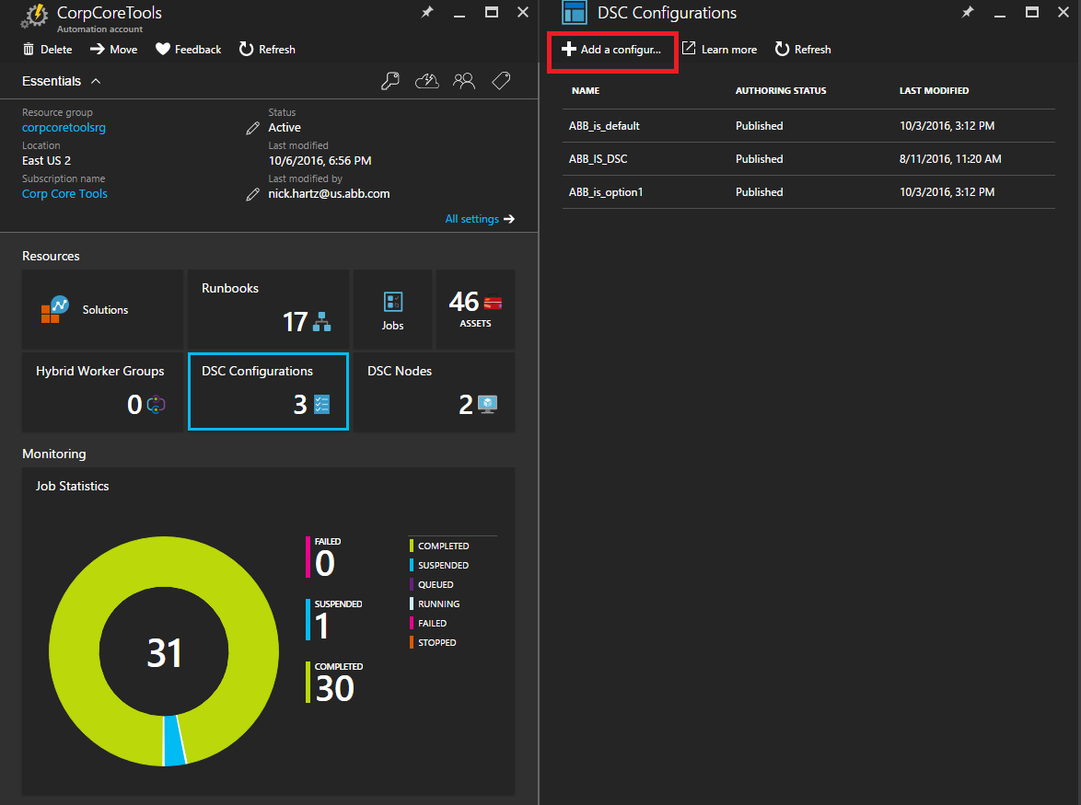

1. On the newly loaded page please select the configuration file you want to upload/update

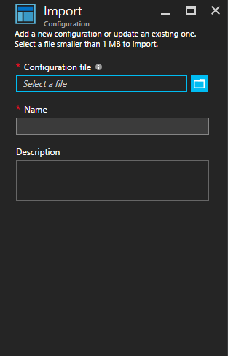

1. Upon selecting your configuration file your information should update and the ok button should now be press able and blue.

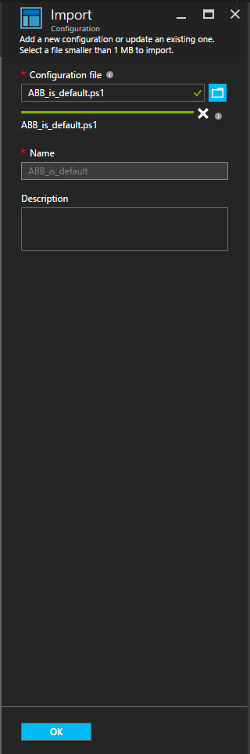

1. Create azure automation variable.

For step by step instructions please see the following [link](https://azure.microsoft.com/en-us/documentation/articles/automation-variables/#creating-a-new-automation-variable):

1. Create azure automation credential asset

For step by step instructions please see the following [link](https://azure.microsoft.com/en-us/documentation/articles/automation-credentials/#creating-a-new-credential-asset):

1. Add modules from powershell gallery

Azure automation now allows you import popular modules from a central source without the hassle of downloading it only to re-upload it to your automation account manually. The following describes steps you would need to take to import modules into your Azure automation account. First proceed to the modules section of your automation account and select the Browse gallery.

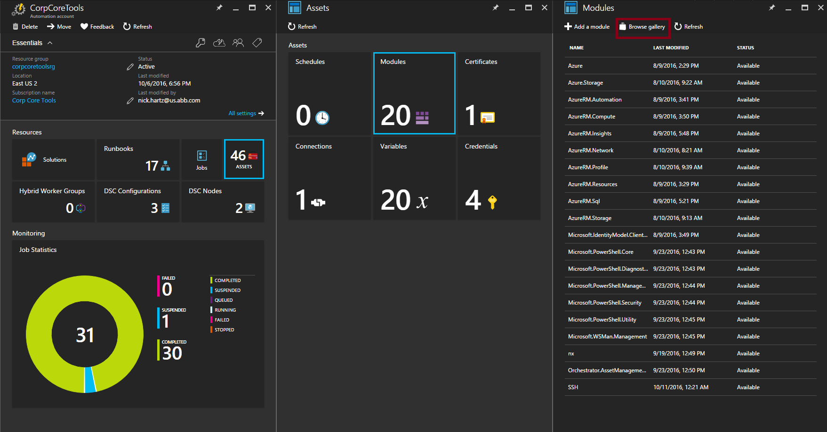

In the gallery option you can search for the module you need to import:

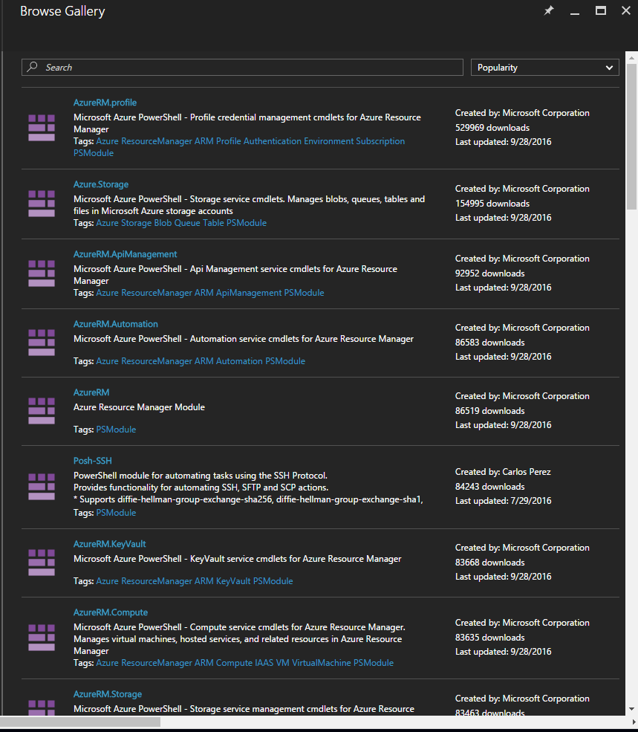

Select the module you want to import and click on the import button.

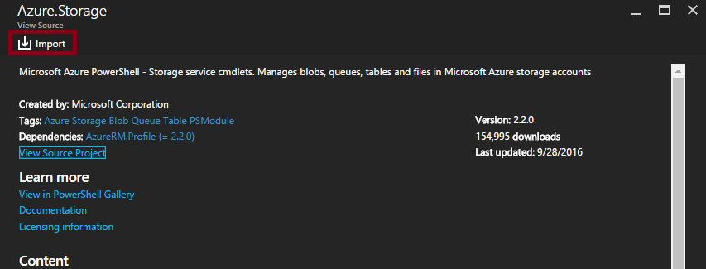

1. Sequence to modify a configuration to add/remove features.

This section would provide general instructions on how you would go about add/remove configuration features.

Perform modification of your dsc configuration file. For resource reference for Linux please see the following [link](https://msdn.microsoft.com/en-us/powershell/dsc/lnxbuiltinresources). For resource reference for Windows please see the following [link](https://msdn.microsoft.com/en-us/powershell/dsc/builtinresource).

Perform steps listed in section 2 of this document.

Execute either rebuildalllinuxcfgs or rebuildallwindowscfgs runbbok.

Log onto the respeective boxes to validate if configuration are successful.

1. Troubleshootin DSC configurations
   1. Troubleshooting Windows configurations

Here is a [link](https://msdn.microsoft.com/en-us/powershell/dsc/troubleshooting) for official troubleshooting steps of DSC issues for windows.

* 1. Troubleshooting Linux DSC configurations.

Here are list of locations for the DSC for linux agent that would prove usefull in your troubleshooting steps:

* /var/opt/microsoft/dsc/cache/, is where packages are downloaded onto the agen6t
* /var/opt/omi/log/dsc.log, is the official dsc agent log
* /opt/microsoft/dsc/Scripts, is where the variaous scripts the DSC agent uses to perform AA related actions.
  + TestDscConfiguration.py: Allows you to provide a test on the currently downloaded configuration.
  + PerformRequiredConfigurationChecks.py: This will force the DSC agent to perform the validation steps all over again. Upon completion you should see a report in AA from the agent.
  + GetDscLocalConfigurationManager.py: This allows you to view the current local configuration of the agent. This comes in handy if you suspect that the agent is under different configurations.
  + GetDscConfiguration.py: Produce the current configuration that is appled to the agent.